Time in Lab
Jacob Vaught | Mady Hines | What was done:
9/12: 3 hours | 9/12: 2 ½ hours | Discussed procedures and delegated.
9/17: 3 hours | 9/17: 3 hours | Did calculations and determined component specifications.
9/19: 6 hours | 9/19: 2 ½ hours | Task 1: Open-loop Control
9/19: 2 hours | 9/19: 3 hours | Worked on/soldered hardware/circuitry of Task 2: Distance Measurement.
9/21: 3 hours | 9/21: 6 ½ hours | Desolder and redo steering hardware for Task 2: Distance Measurement and setup software on microcontroller.
9/24: 3 hours | 9/24: 3 hours | Checked connections and organized hardware and software for Task 1 and 2. Gathered data points and screenshots.

Steering Control (Group B) General

Objectives
❖ Design and implement a steering system using concepts of resonance, amplification and rectification
❖ Design and implement servo-position control for steering Main Specifications
❖ Servo voltage: 4.8V - 6V
❖ Communication frequency: 50Hz
❖ Servo Rotational range: 180⁰
❖ Feedback: LC circuit for a given inductance (at 20 kHz)

Background
We now assume to have a fully operational closed-loop control system capable of setting the vehicle’s speed, measuring that speed, and controlling the speed based on a set point. Since our vehicle is assumed to have forward movement, it is necessary to steer it in order to follow a specified path. The purpose of this lab is to now develop this steering system using a combination of sensor circuitry and software. The track has an embedded wire propagating a 1 amp, 20 kHz square wave signal. We will develop hardware to sense this current and then determine its location in relation to the center of the vehicle so the processor can make appropriate corrections to the steering mechanism.
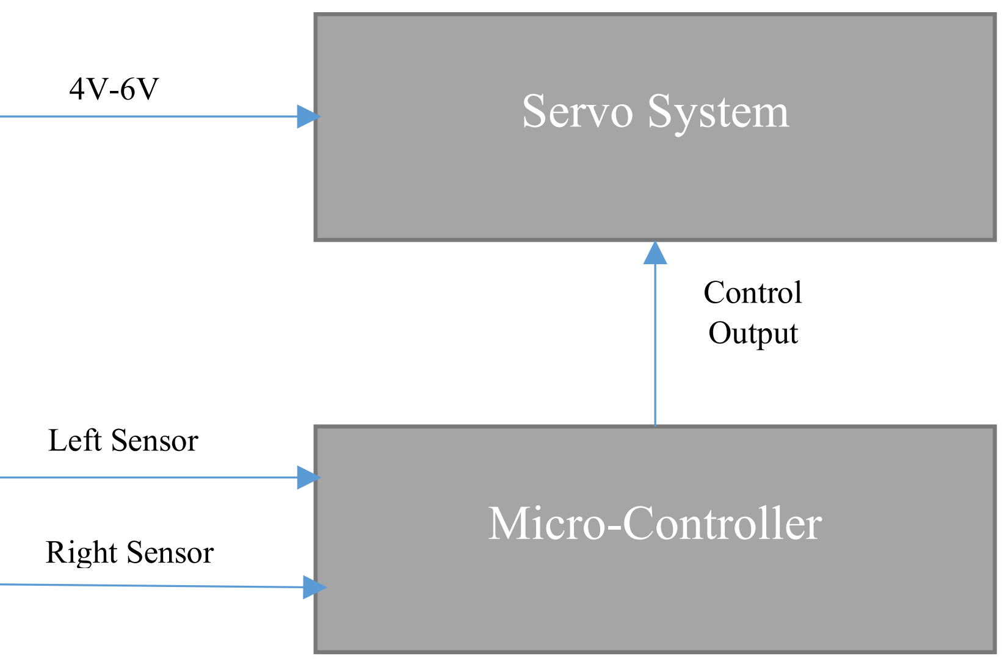
Figure 6 – Steering Diagram
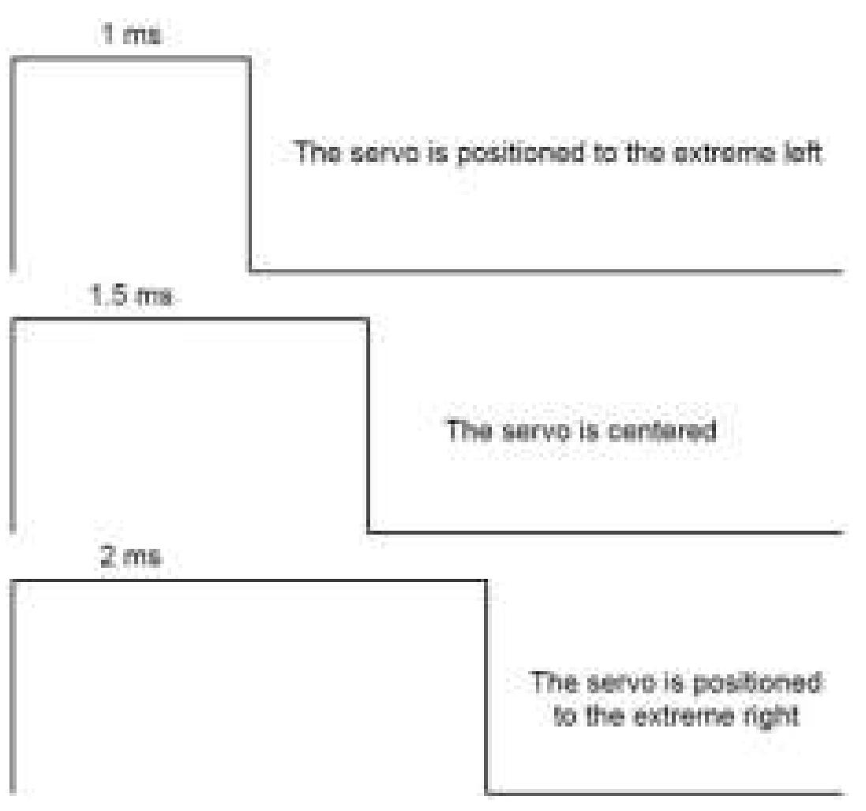
Figure 7 – Servo-Motor Control Signal

Tasks: Open-Loop Control
❖ Design regulation circuit to power servo motor.
❖ Design a voltage divider circuit with an output ranging from 0-3.3V.
❖ Write code that reads in the voltage divider output as an ADC number, and writes the ratio to the desired maximum as the PWM duty cycle.
❖ Upload and verify with microcontroller.
❖ Connect servo-motor to microcontroller.
❖ Servo Control
➢ Use a 50 Hz control signal to the servo
➢ Verify for full range of motion. (0⁰ - 180⁰)

Tasks: Distance Measurement
❖ Research data sheets for components and understand why they are used (their ratings)
❖ Build this circuit and understand how it works.
➢ VCC should be from a laboratory power supply with a 1 Amp current limit.
➢ Gate Signal should be a square wave from a function generator.
▪ High Side greater than threshold voltage
▪ Low Side at common voltage
▪ Frequency of 20 kHz
➢ Why build a track circuit on the desk?
❖ Build this circuit and understand how it works.
➢ Keep the common-mode input voltage range in mind when choosing a LM324 V+
➢ Take screenshots of the signals at N1, N2, and N3
Figure 4. Signal at Node 1 (N1).
Figure 5. Signal at Node 2 (N2).
Figure 6. Signal at Node 3 (N3).

➢ Why is the signal seen at the non-inverting input of the LM324 a sine wave when the track signal is a square wave?
Figure 8 – Steering Hardware Schematic

❖ Tabularize the output from both sensors.
➢ Signal distance from center of car (m)
➢ Vout (V), measurement in volts from sensor
➢ VoutADC, measurement voltage digital conversion
Distance: (m from center, left=negative) | Left Vout (V) | Left Vout ADC (V) | Right Vout (V) | Right Vout ADC (V) | Difference of Left and Right Vout ADC (V) {fig 10}
0 | 0.5 | 3.67 | 0.5 | 3.7 | 0.03
-0.0127 | 2.8 | 3.69 | 0.25 | 2.38 | -1.31
0.0127 | 0.5 | 2.41 | 2 | 3.96 | 1.55
0.0381 | 2.5 | 3.9 | 3 | 4.23 | 0.33
-0.0381 | 3 | 4.5 | 0.5 | 2.5 | -2

❖ Graph the distance of the car to center of track vs output voltage of each sensor
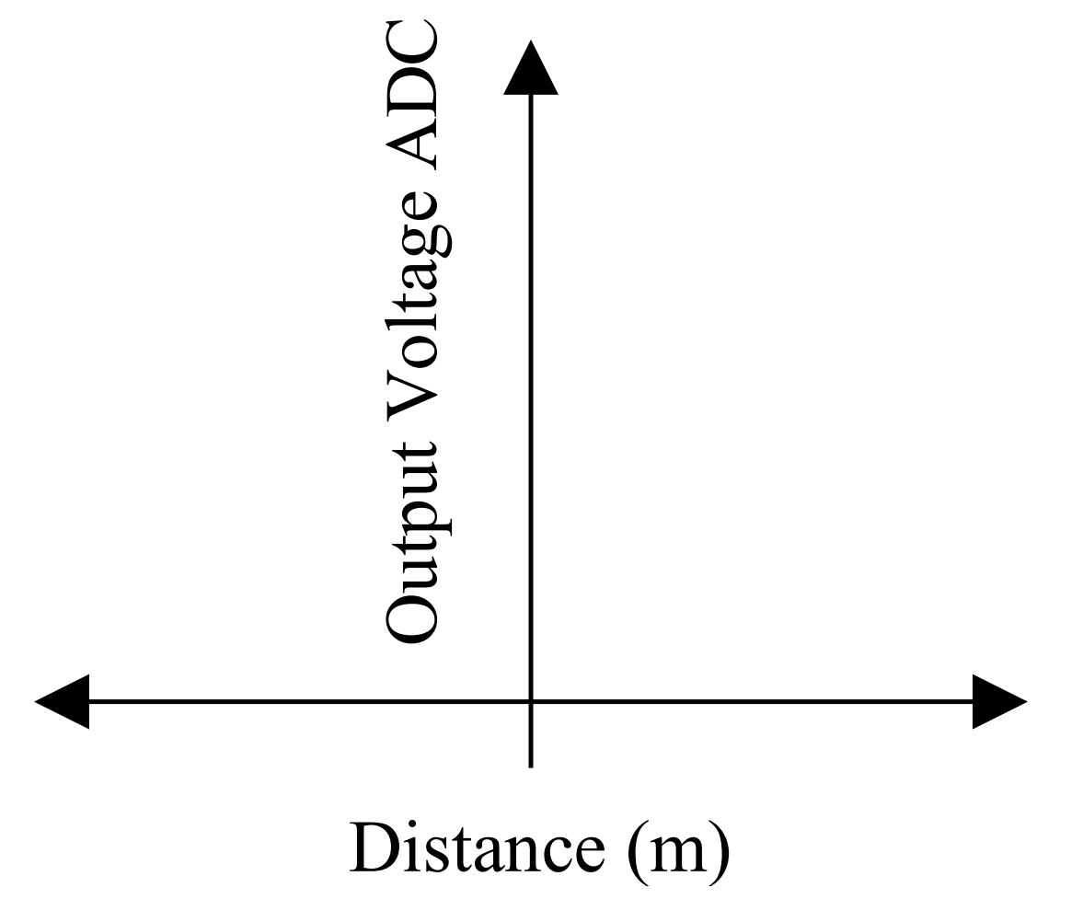
Figure 9 - Required graph summarizing above plot

❖ Graph the distance of the car to center of track vs output difference of the sensors
➢ A check of linearity by using interpolation will complete this lab. Superimpose the average slope on the plot and include the slope’s equation. Output Voltage ADC Distance (m)
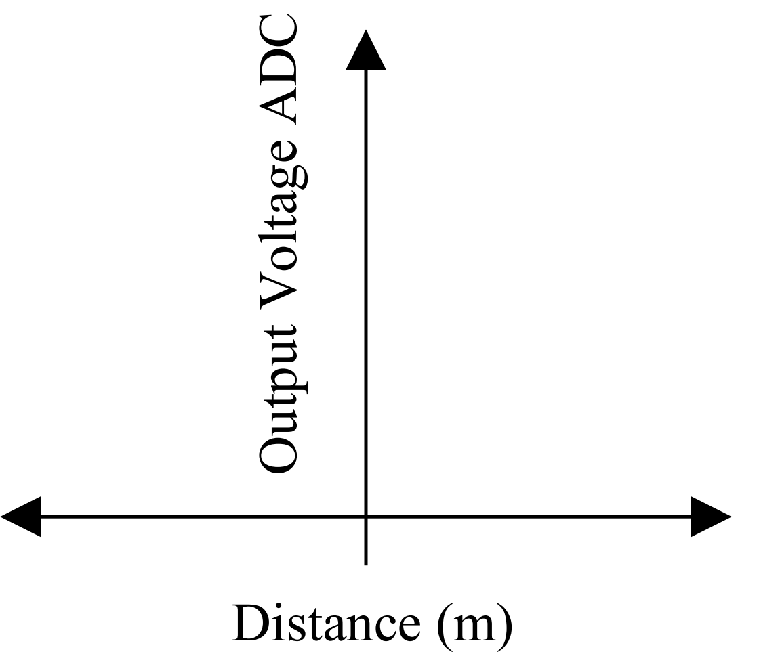
Figure 10 - Required graph for sensor characterization

Questions
- Why create a linear representation of the final graph?
  - To better understand the relationship between the output voltage ADC and the distance (m)/Magnetic Field.
  - It shows the accuracy of the sensors;
- What is the operational range of the sensor?
  - Arduino: 0V-5V
- Is there a delay in the sensor and is this delay negligible?
  - Yes, there is a delay in the sensor, but it is negligible.
- What is the purpose of the two diodes in the circuit? Could one of these diodes be removed?
  - Diodes ae used for conducting the current in one direction (a positive direction).
  - The Zener diode is not necessary and we did not include it in our circuit design.
- What are the four stages of the sensing circuit above?
  - LC Resonate Circuit
    - Inductor: L1
    - Capacitor: C1
  - Amplification Circuit
    - Op-Amp (Operational Amplifier): LM324
    - 2 Resistors: R1 & R2
  - Rectification Circuit
    - Diode
  - Peak Detection Low Pass Filter
    - Capacitor: Cp
    - Resistor: Rp

Check-Off Requirements
➢ Answer questions listed above, and any questions from the instructor and/or TA.
➢ Lab notebook (When? Who? What happened? Schematics and explanations)
➢ Demonstrate open-loop servo control over the entire range. (Servo PWM: 5% - 10%)
➢ Demonstrate feedback covering the entire speed range. (Sensor Voltages: 0.0V – 3.3V)
▪ Both distance sensors must be functional and data recorded at the time of check-off.
➢ Demonstrate the ability to display an ADC or Voltage equivalent value of the two sensor voltages and the difference on the computer from the microcontroller using a serial emulator.
➢ A Table with at least 10 data points shown and measurements/calculations explained for Figure 9.
➢ A Table with at least 10 data points shown and measurements/calculations explained for Figure 10.
➢ A Trend line of the data for Figure 10 with a y-intercept of zero (0V = centered on track), that closely matches the data.

RESULTS
Code:
// Include the mbed and Servo libraries
#include <mbed.h>
#include <Servo.h>

// Define the analog pin connected to the voltage divider
#define ANALOG_PIN (PTE20)
// Define the map function
#define MAP(v, minIn, maxIn, minOut, maxOut) ((v - minIn) * (maxOut - minOut) / (maxIn - minIn) + minOut)

// Create a servo object with pin D4
Servo servo(D4);

// Create an analog input object with pin PTE20
AnalogIn analog(ANALOG_PIN);

int main() {

// Enable servo and set position to -90 degrees
servo.attach(SERVO_POS_MIN);
while(1) {
// Read the analog value from the voltage divider
float value = analog.read();
// Convert the value to a voltage between 0 and 3.3V
float voltage = value * 3.3;
// Map the voltage to an angle between -90 and 90 degrees
int angle = MAP(voltage, 0, 3.3, SERVO_POS_MIN, SERVO_POS_MAX);

// Write the angle to the servo
servo.write(angle);
// Wait for 1 second
wait_us(1000000);
}
}
Diagrams

